# Tilt switch Experiment

## Introduction of Tilt switch

The ball switch, also known as the beaded switch, the steel ball switch, is actually a vibration switch. It has a different name, but it works the same way. The ball ball controls the connection or disconnection of the circuit by contacting or not contacting the pin. Simply put, like turning a light on or off, the light will go on if the switch touches the inner metal plate, and off when the switch leaves. Contact with a metal terminal or changing the path of light with beads in a switch will produce a conductive effect.

Ball switches are widely used, such as: tire pressure monitoring system (TPMS), pedal lamp, digital photo frame rotation, flip camera, anti-theft system, etc. The common spherical switches on the market are sw-200d, sw-300da, sw-520d and so on. The switch used in this experiment is sw-520d, which is OFF in the static state. When it is subjected to an external touch force to achieve the appropriate vibration, or moving at the appropriate speed to generate the appropriate centrifugal force, the needle will instantly be in the ON state, changing the electrical characteristics. When the external force disappears, the electrical characteristics return to the closed state.

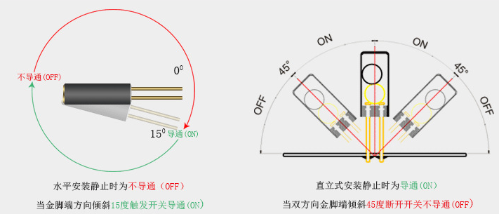

## Ball switch parameters

1. Non-directional, it can be triggered from any Angle

2. Fully sealed package, waterproof and dustproof.

3. Suitable for small current circuit trigger.

4. Double pin, more stable contact.

5. Sensitive, sealed, 12V 0.1ma, turn-on time 0.1ms, open circuit impedance 10M, temperature tolerance 105.

6. Diameter 4.5mm, length 11mm.

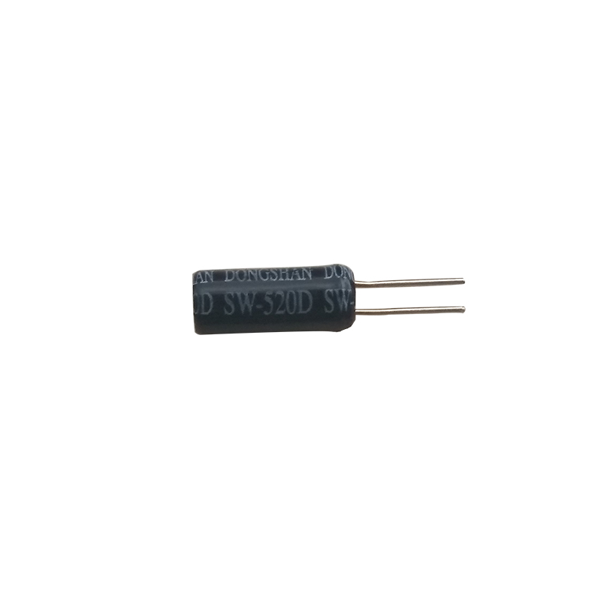

## [Experiment](javascript:;) purpose

## Learn how the sw-520d vibration sensor works, and how to use Arduino to control the sw-520d vibration sensor to realize anti-theft alarm function.

## The component list

* Keywish Arduino Uno R3
* Breadboard *1
* USB cable *1
* Sw-520d vibration sensor * 1
* LED*1
* active buzzer *1
* 10kΩ resistor*1
* Jumper wires

**The experimental principle**

Using the working characteristics of the ball switch, when the circuit board is in the static state, the ball switch is in the on-off state. When an external force touches the circuit board and causes the vibration, the ball switch disconnects, then an alarm is triggered, the LED lights up and the buzzer rings. When the ball switch returns to the on-off state, the LED goes off and the buzzer stops ringing.

## Wiring

|  |  |
| --- | --- |
| Arduino UNO | Active buzzer |
| 13 | + |
| GND | - |

|  |  |
| --- | --- |
| Arduino UNO | SW520D |
| 12 | 1 |
| GND | 2 |

|  |  |
| --- | --- |
| Arduino UNO | 10kΩ resistor |
| 5V | 1 |
| 11 | 2 |

|  |  |
| --- | --- |
| Arduino UNO | LED |
| 12 | + |
| GND | — |

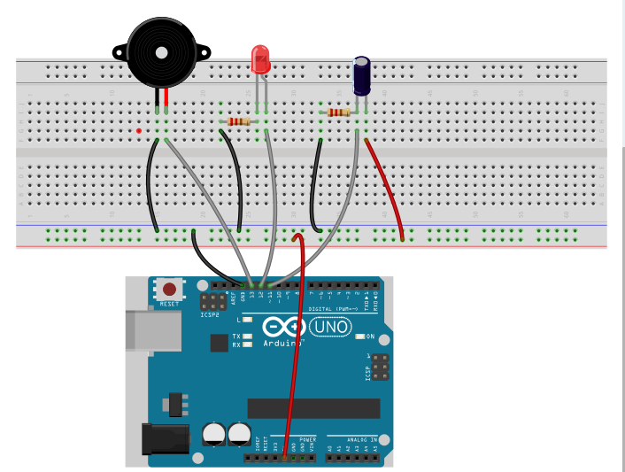

## Code

|  |  |
| --- | --- |
| int Led**=**12**;**  int Buzzer_pin**=**13**;**  int buttonpin**=**11**;**  int val**=**0**;**  void setup**()**  **{**  pinMode**(**Led**,**OUTPUT**);**  pinMode**(**Buzzer_pin**,**OUTPUT**);**  pinMode**(**buttonpin**,**INPUT**);**  Serial**.**begin**(**9600**);**  **}**  void loop**()**  **{**  val**=**digitalRead**(**buttonpin**);**  Serial**.**println**(**val**);**  **if(**val**==**0**)**  **{**  digitalWrite**(**Led**,**HIGH**);**  digitalWrite**(**Buzzer_pin**,**HIGH**);**  delay**(**1000**);**  **}**  **else**  **{**  digitalWrite**(**Led**,**LOW**);**  digitalWrite**(**Buzzer_pin**,**LOW**);**  delay**(**1000**);**  **}**  **}** | int Led**=9;**  int Hall_Pin**=** 8**;**  int val**=**0**;**  void setup**()**  **{**  pinMode**(**Led**,**OUTPUT**);**  pinMode**(**Hall_Pin**,**INPUT**);**  Serial**.**begin**(**9600**);**  **}**  void loop**()**  **{**  val**=**digitalRead**(**Hall_Pin**);**  Serial**.**println**(**val**);**  **if(**val**==**HIGH**)**  **{** digitalWrite**(**Led**,**HIGH**);**  **}**  **else**  **{**  digitalWrite**(**Led**,**LOW**);**  **}**  **}** |

## Experiment Result

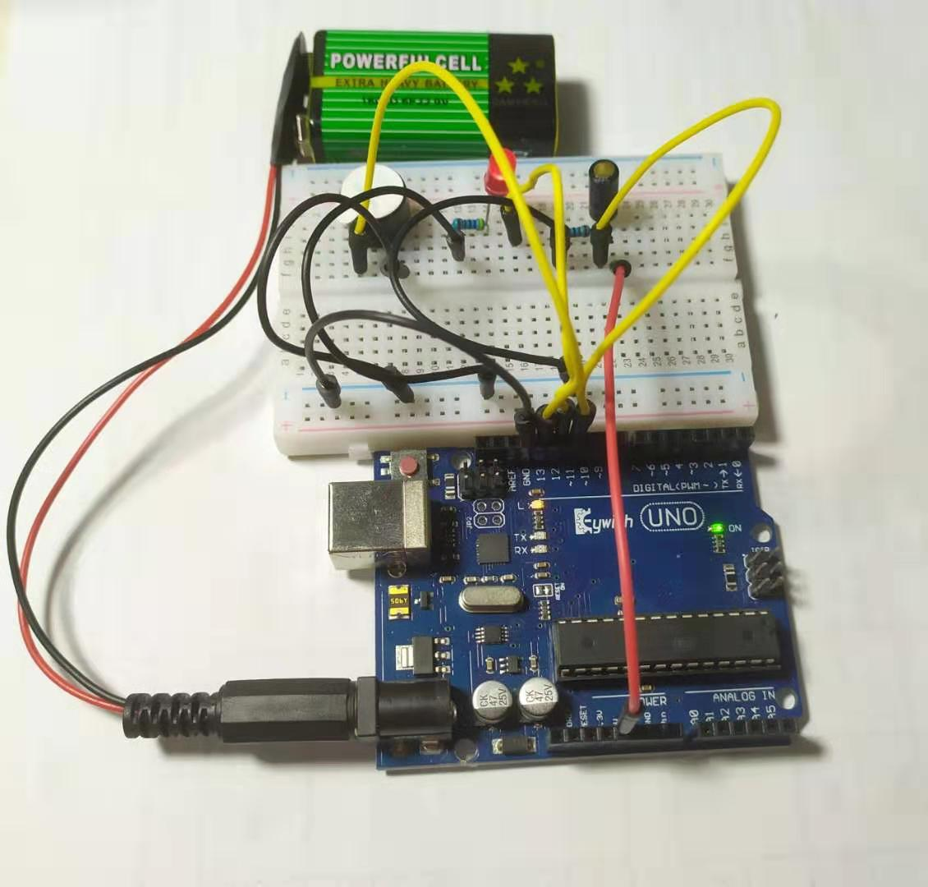

## Mblock programming program

MBlock writes the program as shown in the figure below:

--Set variable read values

--Read the value of the numeric pin

--Serial print variables

--Sets the state of the digital pin output

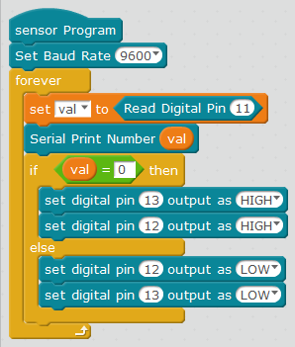

## Mixly programming program

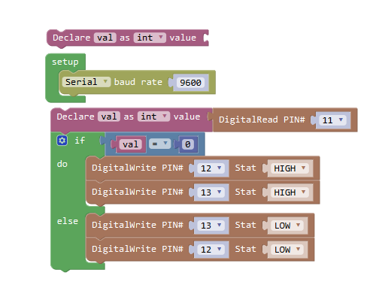

## MagicBlock programming program

